**Blight Burns, Large Open Burns, Field Burning, Recreational Fires, and Special Fires**

**Burn Criteria and Required Permits**

**Bulletin Policy 10-03**

**Reference/s: 2014 OFC Sections 307, Jackson Co Ord 89-10**

There are numerous regulations applicable to different type of fires. Please consult the type of fire and the pertinent requirements listed below that apply to your situation.

**Definitions:**

(1) **Blight Burn** - a controlled means to eradicate various plant diseases by burning an agricultural field or its material.

(2) **Field Burn** - a controlled burn used to clear a piece property or field of brush, weeds, and/or low height vegetation. This is not a blight burn.

(3) **Large Open Burns** - a controlled burning of vegetation, brush, and/or branches, that are configured in piles.

(4) **Recreational Fire -** an outdoor fire, **in fire pits, barbeque pits, or chiminnas**, that burns materials other than rubbish or construction material **not contained or occurring in** an incinerator, outdoor fireplace and portable outdoor fireplace, and has a total fuel area **restricted to 3 feet or less in diameter and 2 feet or less in height** for pleasure, religious, ceremonial, cooking, warmth or similar purposes.

(5) **Prescribed Burn**

(6) **Special Fires** - includes bonfires for celebratory reasons, luau’s or similar type fires.

**When To Burn:**

* During daylight hours only; and
* During burn season but **not during fire season**; and
* On designated burn days when the ventilation index is above 400.
* A burn shall not occur when prevailing winds exceed 15 mph.

**Ventilation Index**

The Ventilation Index (VI) is the [National Weather Service](http://www.wrh.noaa.gov/medford/)'s indicator of the relative degree of air circulation for a specified area and time period. Basically, it is a measurement of the air's ability to "clean" itself.

Call the open/barrel burn advisory at 776-7007 to hear the daily predicted VI and burn status. The predicted VI must be at least 400 to burn during burn season.

For restricted burning requirements from Oregon Dept. of Forestry (ODF) please call ODF at 664-3328 or visit <http://www.oregon.gov/ODF/FIELD/SWO/SWOfire.shtml>

<http://deq12.deq.state.or.us/VIP/default.aspx>

**Burn Alternatives**  
There are cost effective alternatives to burning. Air friendly alternatives to open burning are listed below.

[***Biomass One***](http://www.biomassone.com/)- Located on Avenue G in White City, Biomass has a variety of wood waste recycling programs from home pick-up to a drop-off center. Visit their website or call 826-9422 for more information.

[***Rogue Disposal***](http://www.roguedisposal.com/)- Call 779-4161 for more information about their yard debris, leaf recycling and composting programs.

[***Ashland Sanitary and Recycling***](http://www.ashlandsanitary.com/)- In addition to complete garbage and recycling service, they also have yard debris chipping and leaf disposal services. Visit their website or call 482-1471.

[***Jackson County Leaf Exchange Program***](http://www.co.jackson.or.us/page.asp?navid=2481)– Connects people who are trying to get rid of leaves with people who want leaves. Call 774-8207 to be put on the recipient/donor list or to be connected with someone to exchange leaves.

[***Hilton Fuel***](http://hiltonlandscapeandsupply.com/wood_waste_drop_off.html) – Located in Central Point, Hilton fuel will accept clean wood only. Call 664-3374 for more information.

**Blight Burns**

**Burn Criteria:**

* A plowed 30-foot wide strip around the edge of the burn area.
* Provide a vehicle with a water tank with a minimum 500 gallon water capacity;
* Water tanks shall be equipped with a pump, hose, and nozzle to extinguish any fires starting outside the burn area.
* The fire is to only occur during daylight hours, flames out by sunset, and to be constantly attended at all times until the fire is extinguished.
* It is preferred that the fire be started on the upwind edge using the prevailing winds and burn the pile or toward the center of the field.
* A burn shall not occur when prevailing winds exceed 15 mph.

**Open Burn, Pile(s)**

**Burnable Material:**

* Yard trimmings, leaves, vegetation, brush, and branches can be burned. **Do not burn** stumps, garbage, tires, furniture, petroleum based products, plastic, etc.

**Pile Size:**

* Piles that exceed (3x2) feet shall require preapproval and site inspection before the burn.

**Pile Preparation:**

* Piles must be at least 50 feet from buildings, wood piles, fences, propane tanks, and/or combustible material.
* Piles shall have at least a 17-foot separation.
* Plow a barrier around the pile.
* A plowed 17-foot wide strip around the pile perimeter; or
* A 5-foot wide strip around the field perimeter, and remove and cut down grass/brush for a 12-foot wide strip adjacent to the 5-foot wide strip; or
* A 17-foot wide strip of green cover crop or bare earth.

**Water Supply:**

* Up to three piles shall have **at least one** water tank with a minimum 1,000 gallon water capacity.
* Over three piles shall have **at least two** water tanks with a minimum 1,500 gallon water capacity.
* Piles smaller than 12x12 can use a garden hose connected to a home’s domestic supply.

**Firefighting Equipment:**

* All water tank vehicles shall be equipped with an operable pump with a capacity of at least 30 gpm, a hose, and nozzle.
* Provide the vehicles with trained operators and it is recommended to have at least two operators.
* Water tankers shall be filled to 90 percent capacity before to the field burn.

**Means of Communication:**

* Have the ability to call for assistance or 9-1-1 at all times.

**Fire Safety Watch:**

* Provide a continuous fire watch.
* Patrol the perimeter of the field during the burn.
* Continue the watch for at least 30 minutes after the flame ceases.
* Shall have a firefighting vehicle with a water tank with at least a 200 gallon capacity with a pump and ability to pump 30 gpm.

**Wind Conditions:**

* A burn shall not occur when prevailing winds exceed 15 mph.

**Field Burn**

OAR 837-110-0010 through 0090

**Field Preparation:**

Plow a barrier around the field

* A plowed 17-foot wide strip around the field perimeter; or
* A 5-foot wide strip around the field perimeter, and remove and cut down grass/brush for a 12-foot wide strip adjacent to the 5-foot wide strip; or
* A 17-foot wide strip of green cover crop or bare earth; or
* At least a 50-wide strip of green cover crop or bare earth in the adjacent field(s) at time of burning.

**Water Supply:**

* Up to 50 acres **at least two** water tanks with a minimum 1,000 gallon water capacity;
* 50 to 200 acres **at least three** water tanks with a minimum 1,500 gallon water capacity;
* Over 200 acres **at least four** water tanks with a minimum 3,000 gallon water capacity;

**Firefighting Equipment:**

* All water tank vehicles shall be equipped with an operable pump with capacity of at least 30 gpm.
* Staff the vehicles with trained operators and it is recommend having at least two operators.
* Water tankers shall be filled to 90 percent capacity before to the field burn.

**Burn Method:**

* When possible, start the burn on the edges of the field and burn towards the center of the field.
* Recommend burning to occur in the morning hours.

**Means of Communication:**

* Have the ability to call for assistance or 9-1-1 at all times.

**Fire Safety Watch:**

* Provide a continuous fire watch - patrol the perimeter of the field during the burn.
* Continue the watch for at least 30 minutes after the flame ceases.
* Shall have a firefighting vehicle with a water tank with at least a 200 gallon capacity with a pump and ability to pump 30 gpm.

**Traffic Safety:**

The person responsible for the burn shall provide signage and trained flaggers for traffic safety. The person responsible may allow:

* A field to burn next to a state highway without designated buffer zones or next to an arterial route as long as there are trained flaggers and warning signage on the road at both ends of the field during the time that the burning is occurring, in order to assure driver safety and stop or divert traffic if necessary. Burning may occur next to a state highway without designated buffer zones or an arterial route only if there are no combustibles or brush between the edge of the field and the highway or route.
* A field to burn next to a rural collector road as long as there is signage on the road at both ends of the field informing drivers that burning is occurring ahead and they should be prepared to stop. Trained flaggers shall be available in the vicinity to immediately respond with flagging signs to the road at both ends of the field during the time that the burning is occurring, in order to assure driver safety and stop or divert traffic if necessary. Burning may occur along a rural collector road only if there are no combustibles or brush between the edge of the field and the rural collector road.
* May allow a field to burn next to a rural local service road as long as there is signage on the road at both ends of the field informing drivers that burning is occurring ahead. Trained flaggers shall be available to be on the road with flagging signs at both ends of the field during the time that the burning is occurring, in order to assure driver safety and stop or divert traffic if necessary.

**Wind Conditions:**

* A burn shall not occur when prevailing winds exceed 15 mph.

**Recreational Burn Pits**

The following does not apply to gas (natural or LP) pits.

**Fire Pits including those in the ground:**

* Locate the fire pit in a clear area at least 15 feet from structures, combustible vegetation, fences, overhangs, and property lines.
* Grasses and weeds within 15 feet of the pit shall be cut to ground level unless the grass is green and cut.
* Fuel shall be limited to wood or charcoal.
* Provide a garden hose, attached to a water supply, which will reach the area of the pit.
* Provide a shovel.
* The fire will be constantly attended and supervised by an adult.

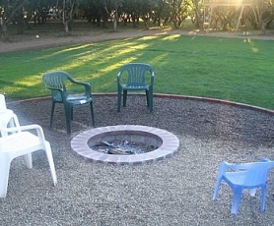

Fire Pit Fire Pit

Below are **commercially purchased fire pits and chiminnas** typically designed for use on a patio. They should be used with screens or spark arrestors. They are not regulated by the requirements listed above but shall not be used during high or extreme fire conditions. Contact ODF at (541) 664-3328 or go to <http://www.swofire.oregon.gov/> . Provide a noncombustible surface (masonry bricks) to set these units on.

[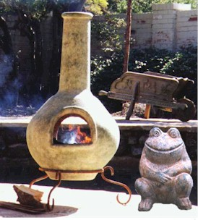](http://www.dancingfire.com/chimenea)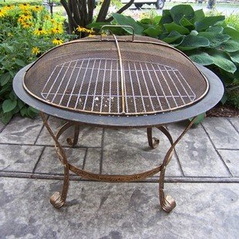

Prefab-fire pit Chiminnas

**Burn Barrels**

Burn barrels shall be at least 15 feet of clearance from structures, combustible vegetation, fences, overhangs, and property lines.

Grasses and weeds within 15 feet of the burn barrel shall be cut to ground level unless the grass is green and cut.

**Barrel burning is prohibited...**

* Throughout Jackson County when the Ventilation Index (VI)* is below 400.
* Within the Air Quality Maintenance Area during November, December, January and February.
* In Jackson County during the fire season.

**Special Burns**

**Permit**

Special burns requires a permit with an approval signature from the Fire & Life Safety Department.

**Burn Criteria**

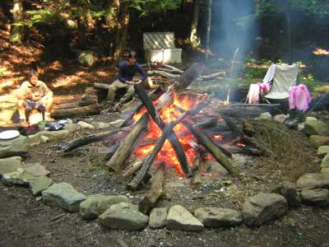**Bonfires**

* **Not Permitted** during fire season.
* During daylight hours only except when the pile size is limited to 6’ L by 6’ W by 6’ H for night burns.
* A burn shall not occur when prevailing winds exceed 15 mph.
* Are permitted when the ventilation index is above 400.
* Pile size for daylight shall not exceed 12’ L x 12’ W x 8’ H.
* Piles must be at least 50 feet from buildings, wood piles, fences, propane tanks, and/or combustible material.
* Plow or provide a barrier around the pile. (For the small night bonfire noted above, the following clearances may be reduced by half.)
* A plowed or clear 20-foot wide strip around the pile perimeter; or
* A 5-foot wide strip around the field perimeter, and remove and cut down grass/brush for a 15-foot wide strip adjacent to the 5-foot wide strip; or
* A 20-foot wide strip of a maximum of 6” in height green vegetation or bare earth.
* A bonfire shall not be placed under power lines but at least 20-foot horizontal distance away from being under the power lines.

**Burnable Material:**

* Yard trimmings, leaves, brush, lumber, and wood can be burned. Do not burn garbage, tires, furniture, petroleum based products, plastic, construction materials, etc.

**Pile Size:**

* Piles that exceed 4 feet by 4 feet shall also require preapproval and site inspection before the burn.

**Water Supply:**

* The site shall have **at least one** water tank with a minimum 1,000 gallon water capacity, or a preapproved alternate. For the small night bonfire noted above, the water capacity may be reduced by half.

**Firefighting Equipment:**

* The water tank vehicle shall be equipped with an operable pump with a capacity of at least 30 gpm, a hose, and nozzle.
* Provide the vehicles with trained operators and it is recommended to have at least two operators.
* Water tankers shall be filled to 90 percent capacity before to the field burn.

**Means of Communication:**

* Have the ability to call for assistance or 9-1-1 at all times.

**Fire Safety Watch:**

* Provide a continuous fire watch and patrol the area around the bonfire during the burn to check for spot fires.
* Continue the watch for at least 30 minutes after the flame ceases.

**Luau (underground pig roast) or similar type fire**

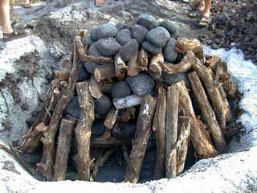**Preparation Fire:**

* During daylight hours only unless preapproved.
* Locate the fire pit in a clear area at least 25 feet from structures, combustible

vegetation, fences, overhangs, and property lines.

* Provide constant supervision by an adult who will provide a fire watch.
* A burn shall not occur when prevailing winds exceed 15 mph.
* A fire shall not be placed under power lines but at least 10-foot horizontal distance from being under the power lines.
* Are permitted when the ventilation index is above 400.
* A 20-foot wide clear strip around the fire shall be provided. Within the strip, any grass/weeds shall be cut to ground level, loose brush and leaves shall be removed, and trees shall be have limbs removed to ten feet above ground level.
* A continuous water source (garden hose) shall be provided that can reach 30 feet beyond the fire in all directions.
* Have the ability to call for assistance or 9-1-1 at all times.

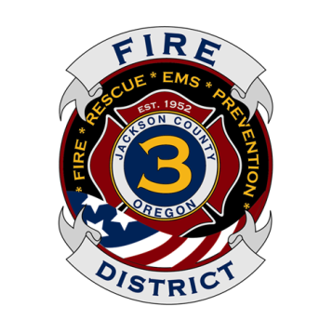

**Jackson County Fire District 3**

8383 Agate Road

White City, OR 97503-1075

(541) 826-7100 (Office)

(541) 826-4566 (Fax)

www.jcfd3.com

**­­­**

**Special Burn Permit**

**This is a one time use unless Inspector gives approval.**

**Submit to the office before a burn or fax it to (541) 826-4566.**

**IMPORTANT: The site must be inspected by a Fire official before burning occurs.**

**Call the office to make an inspection appointment.**

**Please mark the type of burn that will occur:**

□ Field Burn □ Open Burn Pile(s) □ Bonfire □ Luau Type Fire □ Prescribed Burn

Date(s) of Burn: Time/Duration of Burn:

Business/Owner Address:

Burn Site Address:

Contact Person: Cell Phone:

Other Requirements:

Inspector Comments for Other Than One Time Use:

Insp. Signature

**For Office Use Only:**

Fax received by:

Fire Official Approval: Date:

**An on-site inspection will be conducted before the burn is allowed: Yes No**

Notifications:

□ ECSO notified □ E-mailed or □ Paged: BC.s, Duty Officer, and Front Counter Staff

Same burn called in for each date:

**The Department has a right to refuse the issuance of a permit if it is deemed an unreasonable risk.**